Next Steps for Your Wildfire Preparedness Mini Grant


Scan here for the online application hub
- Make sure your project falls under an NRSC or WRN standards. If you’re project affects trees, make sure to contact a licensed tree service provider
- Create your project design, a simplified site plan showing the general location of your project(s), its dimensions, and the dimensions of your property. Project designs may be hand drawn and do not need to be to scale.
- Estimate your budget by either filling out our budget estimate worksheet or getting a quote from a local landscaper/contractor.
- Take a few before photos of where your project will go.
- Fill our our online application before grants are due on Tuesday, December 31st, 2024. Submit your budget estimate, project scope, before photos, and any other documents you want to include along with your application.

Project Type | Description |  | Project Life
Brush Management 314 | Control undesirable woody plants in a manner that creates the desired plant community, including the desired fuel load, to reduce the risk of wildfire. |  | 1 Year
Firebreak 394 | Ground cleared to bare soil or planted with fire-resistant vegetation meant to stop the spread of fire. |  | 5 Years
Forest Stand Improvement 666 | Manage stocking rates and alter spatial arrangement of trees to reduce wildfire hazard. |  | 10 Years
Fuel Break 383 | Cutting down and regular management of fuel sources |  | 10 Years
TreeShrub Pruning 660 | Maintain the health and vigor of trees and shrubs by removing the minimum amount of living biomass required to achieve the pruning objective. |  | 10 Years
Wood Chipper 384 | Chipping, masticating, crushing, compacting, lop and scatter, piling, burning, and offsite removal |  | 10 Years
Wildfire Ready Neighbors BMPs | Roof cleaning, gravel installation, fire-resistant planting, public outreach |  | Varies

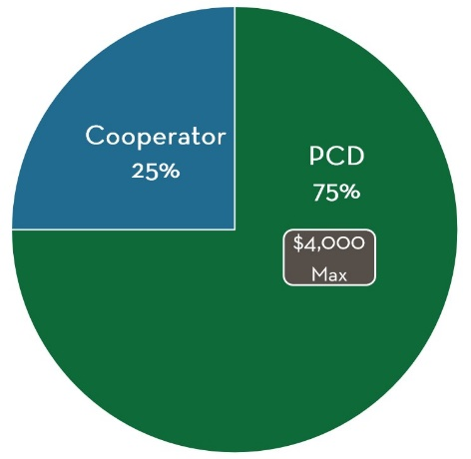
Cost Share: PCD will cover 75% of the total cost of the project up to $4,000. Projects can be funded in two ways:
- Reimbursement. If you would like to hire your own licensed contractor or purchase your own materials, you are free to do so! Keep your receipts and submit them for reimbursement after the project is complete.
- Direct Pay. If you aren't able to pay for things up front or don’t want to manage your project, no problem! PCD is able to hire contractors and pay for project materials directly. After the project is complete, PCD will send you an invoice for your portion of the cost share.

Grant Scoring and Assessment: Applications will be reviewed be a committee of PCD staff and local fire experts. Each application will be assessed on: Equity (25%), Community Impact (25%), Wildfire Impact (25%), and Personal Impact (25%).

For more information on mini-grant scoring, visit our website at [To be Determined]

General 2024/2025 Project Timeline:

- January/February: Notice of Awards are sent to grant recipients. Additional paperwork is completed by both parties.

- March/April: Grant recipients meet with PCD and/or contractors to take the initial project scope and develop a full, tool-ready plan.

- May/June: Projects are completed

